# REPORT OF AWS PROJECT-DOCUMENTATION

DATE:29th september,2023

**TEAM MEMBERS:**

**A.MADHUR(22A81A05K1)**

**CH.LOKESH (22A81A05L2)**

**G.BLESSIN SATWIK(22A81A05M3)**

**N.RATNA SITARA(22A81A05N4)**

**V.HARIKA SRI(22A81A05Q1)**

**V.VINITHA(22A81A05Q3)**

VENUE:Sri Vasavi Engineering College

### INTRODUCTION TO AWS:

AWS (Amazon Web Services) is a comprehensive cloud computing platform offered by Amazon.com. It provides a wide range of cloud services that enable businesses and individuals to build and deploy applications and infrastructure in a flexible, scalable, and cost-effective manner. AWS offers a robust set of tools, technologies, and services that cater to various computing needs, including storage, networking, databases, machine learning, analytics, and more.

### OVERVIEW OF AWS:

Cloud computing is now an essential part of all businesses in every industry.

Amazon Web Services is a prevalent form that increases efficiency while

assisting several business practices. Dating back to the 2000s, organizations

depended absolutely on servers that are purchased servers. In contrast, such

servers had functions that are limited with steep prices, including a server that is

functioning requiring numerous validations.

The more business keeps experiencing growth, the more optimization practices

and servers are needed. Getting such items showed unproductively and at times

excessively costly.

The benefits of Amazon Web Services have been the answer to many problems.

Organizations that use AWS have instantly available servers; also, AWS offers

various improved storage options, workloads, and enhanced security measures.

### HISTORY OF AWS:

Amazon Web Services was launched in 2002. The company intended to sell the

infrastructure that is not in use as a service or offering it to customers, wherein

the purpose was met enthusiastically. Amazon had its first AWS product

launched in the year 2006. After four years, in the year 2012, Amazon had a

huge occasion to gather customer input concerning AWS. To date, the

organization continues to hold similar events, like Reinvent, that lets customers

share feedback concerning AWS.

In 2015, Amazon publicized that the revenue of AWS has amounted to $7.8

billion. From then and 2016, measures had been launched by AWS aiding

customers to migrate their services to AWS. Such actions, including the growing

and appreciating features of AWS, made further economic growth. In the year

2016, Amazon’s revenue augmented to $12.2 billion in 2016. Presently, AWS

provides customers with 160 products and services.

### Benefits of AWS:

**Easy to use**

AWS is designed to allow application providers, ISVs, and vendors to quickly and securely host your applications – whether an existing application or a new SaaS-based application. You can use the AWS Management Console or well-documented web services APIs to access AWS’s application hosting platform.

**Flexible**

AWS enables you to select the operating system, programming language, web application platform, database, and other services you need. With AWS, you receive a virtual environment that lets you load the software and services your application requires. This eases the migration process for existing applications while preserving options for building new solutions.

**Cost-Effective**

You pay only for the compute power, storage, and other resources you use, with no long-term contracts or up-front commitments. For more information on comparing the costs of other hosting alternatives with AWS, see the AWS Economics Center.

**Reliable**

With AWS, you take advantage of a scalable, reliable, and secure global computing infrastructure, the virtual backbone of Amazon.com’s multi-billion dollar online business that has been honed for over a decade.

**Scalable and high-performance**

Using AWS tools, Auto Scaling, and Elastic Load Balancing, your application can scale up or down based on demand. Backed by Amazon’s massive infrastructure, you have access to compute and storage resources when you need them.

**Secure**

AWS utilizes an end-to-end approach to secure and harden our infrastructure, including physical, operational, and software measures. For more information, see the AWS Security Center.

Services that are commonly used and provided by

### Amazon Web Services

1. Compute Services:

- Amazon Elastic Compute Cloud (EC2): Provides virtual servers in the cloud, allowing users to quickly scale computing resources.

- AWS Lambda: Enables serverless computing, allowing developers to run code without managing servers.

2. Storage Services:

- Amazon Simple Storage Service (S3): Offers scalable object storage for storing and retrieving data.

- Amazon Elastic Block Store (EBS): Provides persistent block-level storage volumes for EC2 instances.

3. Database Services:

- Amazon Relational Database Service (RDS): Managed relational database service supporting multiple database engines.

- Amazon DynamoDB: Fully managed NoSQL database for high-performance applications.

4. Networking Services:

- Amazon Virtual Private Cloud (VPC): Offers isolated virtual networks in the AWS cloud.

- AWS Direct Connect: Provides dedicated network connections between on-premises environments and AWS.

5. Machine Learning and AI Services:

- Amazon SageMaker: Fully managed machine learning service for building, training, and deploying models.

- Amazon Rekognition: Deep learning-based image and video analysis service.

- Amazon Comprehend: Natural language processing service for analyzing text.

6. Analytics Services:

- Amazon Redshift: Data warehousing service for analyzing large datasets.

- Amazon Athena: Serverless interactive query service for analyzing data stored in S3.

7. Security and Identity Services:

- AWS Identity and Access Management (IAM): Manages user access and permissions to AWS resources.

- Amazon Cognito: Provides user authentication and authorization for mobile and web applications.

8. Deployment and Management Services:

- AWS CloudFormation: Infrastructure as code service for provisioning and managing AWS resources.

- AWS Elastic Beanstalk: Platform as a service (PaaS) for deploying and managing applications.

**LEVEL-1**

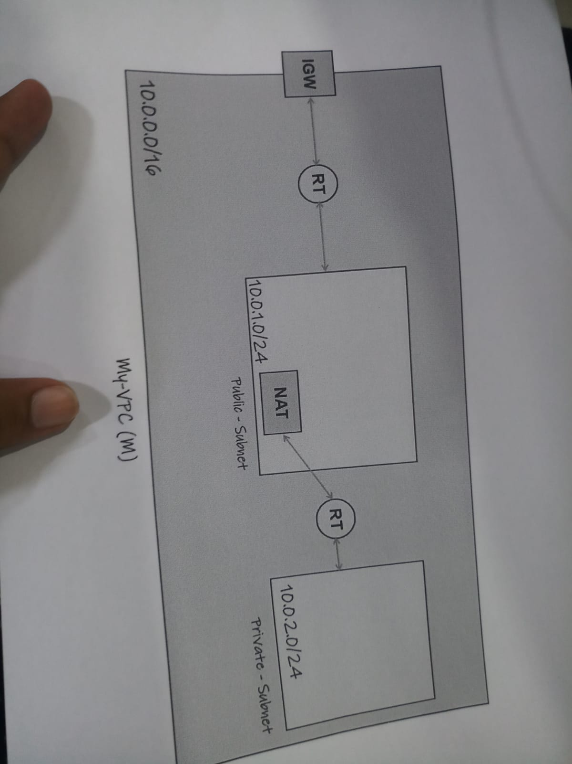

**VPC (Virtual Private Cloud)** is an AWS service that allows users to create and manage their own isolated virtual network within the AWS cloud. It provides a secure and private environment for running applications and services. The main components of VPC are:

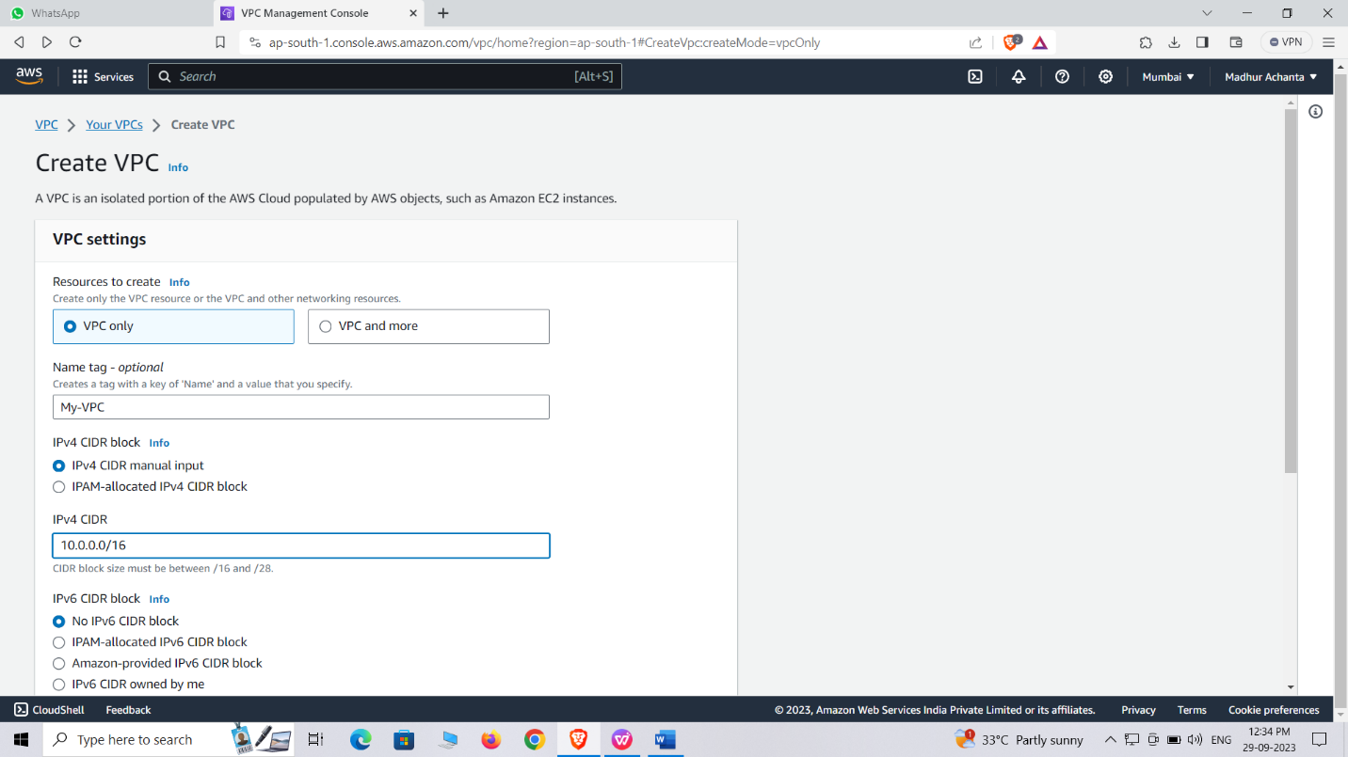

**Part:- 1**

**Create a VPC:-**

Click on the search bar and search VPC, click on it and go to your VPC’s

Create VPC’s

Now click VPC only

Enter name tag as MY-VPC

Enter IPV4 CIDRvas 10.0.0.0/16

Click create VPC

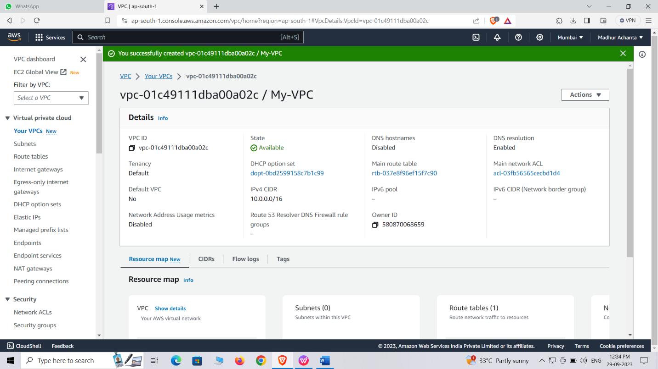

Hence you’re VPC has been created

**Part:- 2**

**Create subnets :**

**Subnets:** Subnets divide the IP address range of a VPC into smaller segments and are associated with specific availability zones (AZs) in a region.

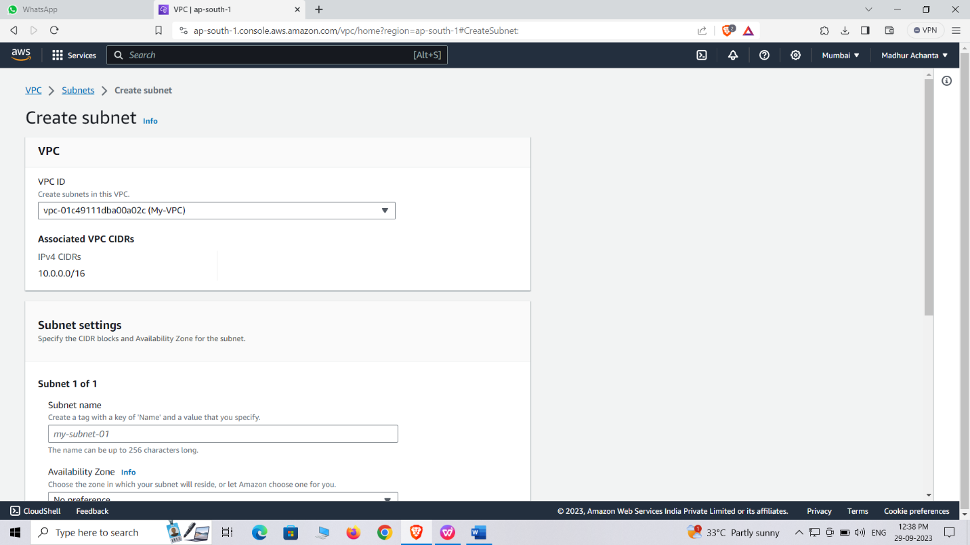

Create Subnets:

Click on "Subnets" in the left-hand navigation pane.

Click on "Create subnet" and provide it with name VPC MY-VPC

Enter subnet name as 10.0.1.0/24-1a-PUB.

Set availability zone as 1a enter CIDR as 10.0.1.0/24

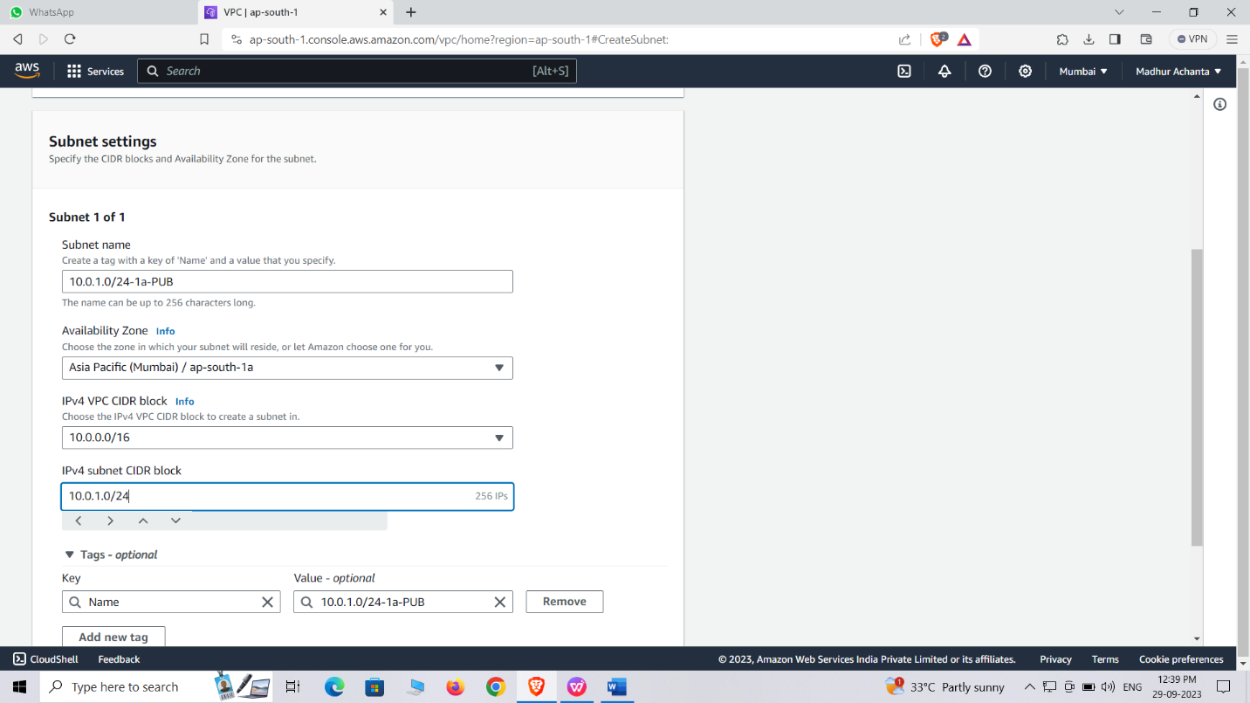

Click add new subnet

Give name as 10.0.2.0/24-1b-PVT

Set availability region as 1b

Give CIDR as 10.0.2.0/24

Click on create subnet

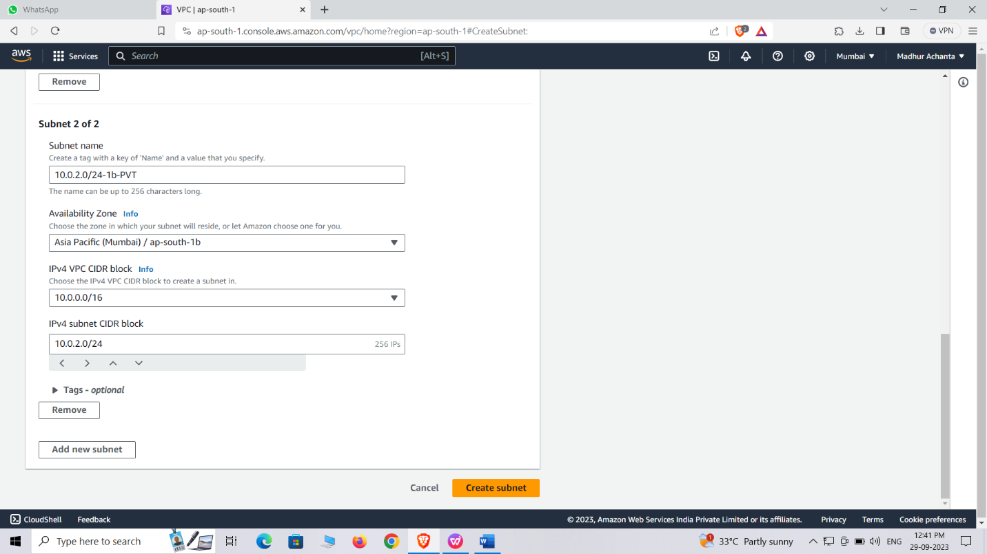

Hence you’re subnet has been created

Part :-3

Changing subnet into PUBLIC

At beginning all the created subnets are in the PRIVATE so we should make one subnet into PUBLIC

Click required subnet which you want to make a PUBLIC

And then click on the actions then edit subnet settings

Now enable auto assign PUBLIC IPV4 then save it

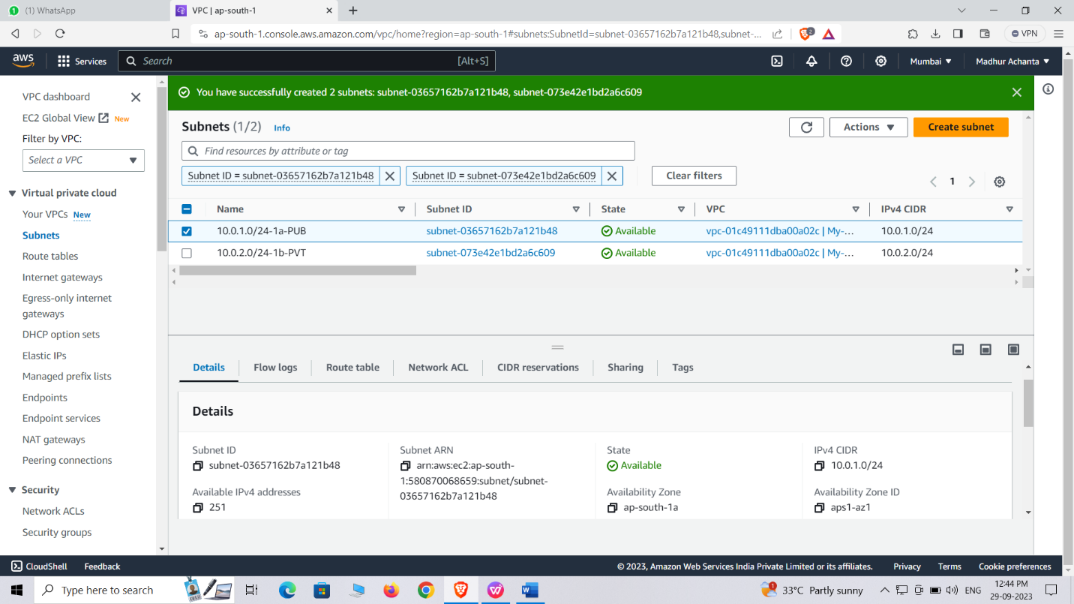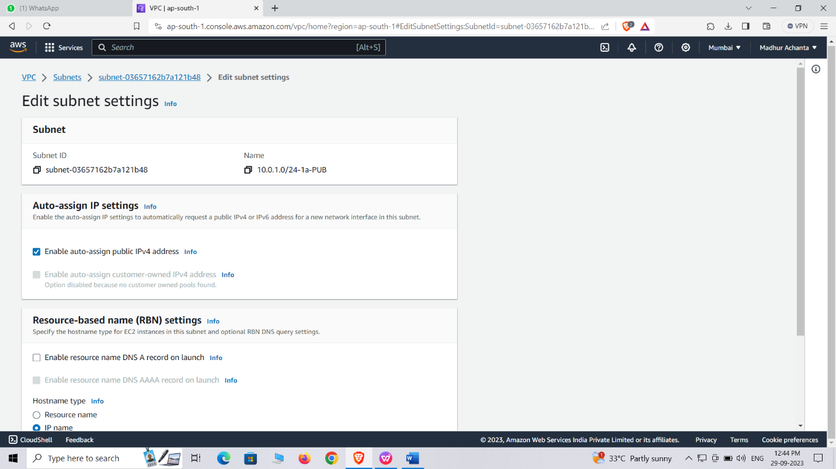

Part :-4

Creating IGW(internet gate way)

**Internet Gateway:** An Internet Gateway enables communication between a VPC and the internet.

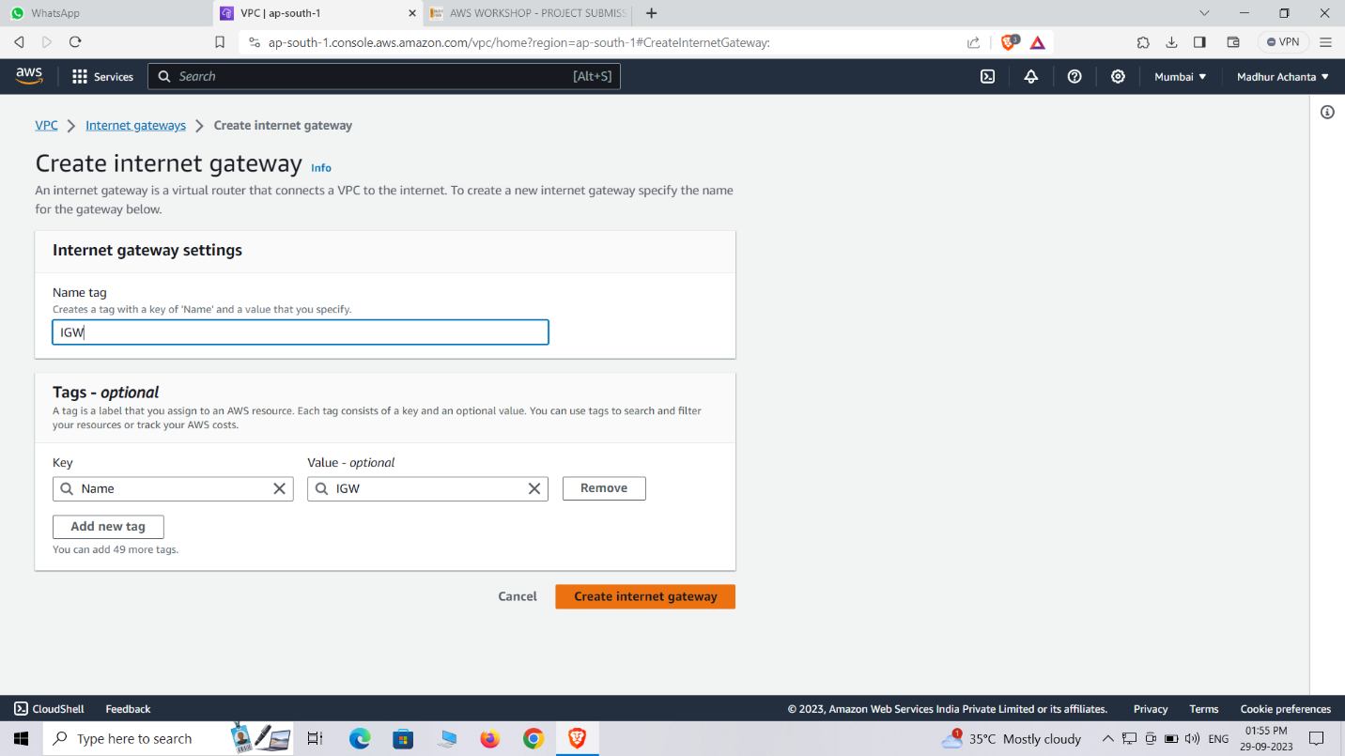

Create an Internet Gateway:

Click on "Internet Gateways" in the left-hand navigation pane.

Click on "Create internet gateway"

Give a name tag –IGW

Create IGW

Now click on the actions then attach to the VPC

Select MY-VPC which we created and then click attach IGW

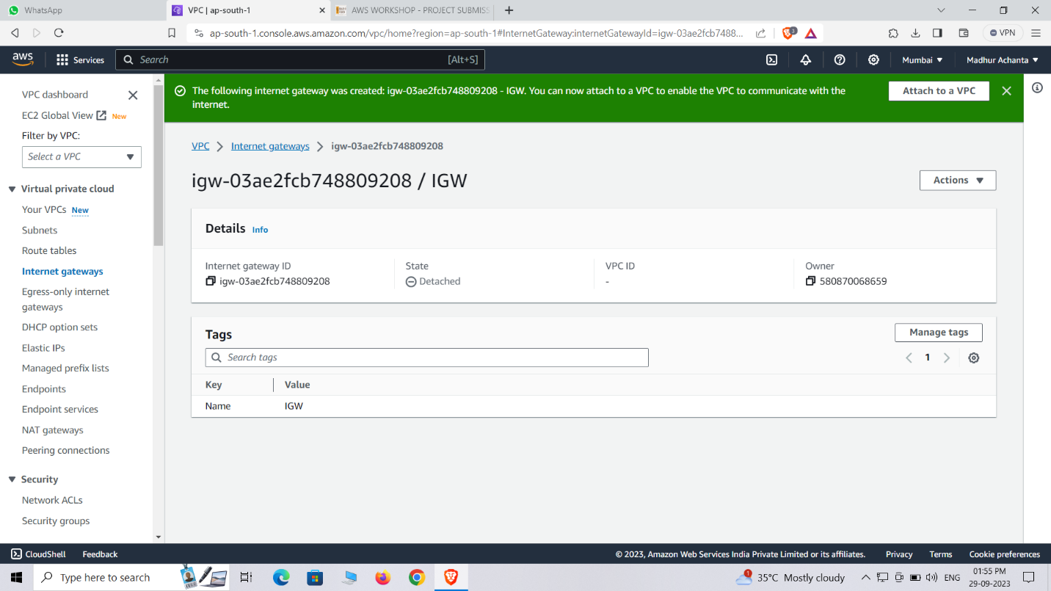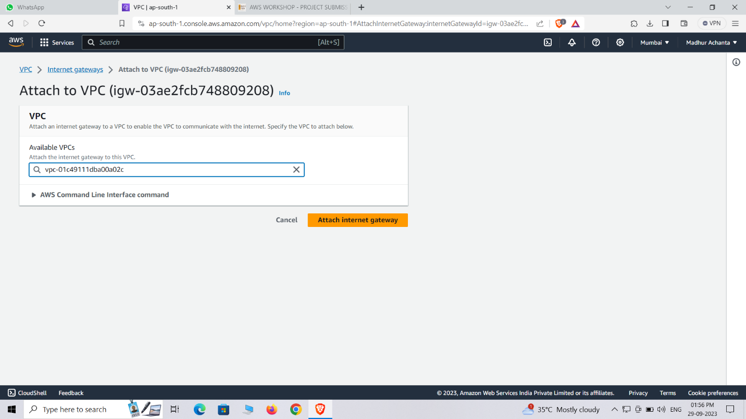

PART:-5

Creating Route tables

For creating route tables click on route tables

R**oute table** is a networking component in AWS that controls the traffic flow within a VPC by specifying the destination and target for network packets, determining where they should be sent. It acts as a routing guide for incoming and outgoing network traffic in a virtual network.

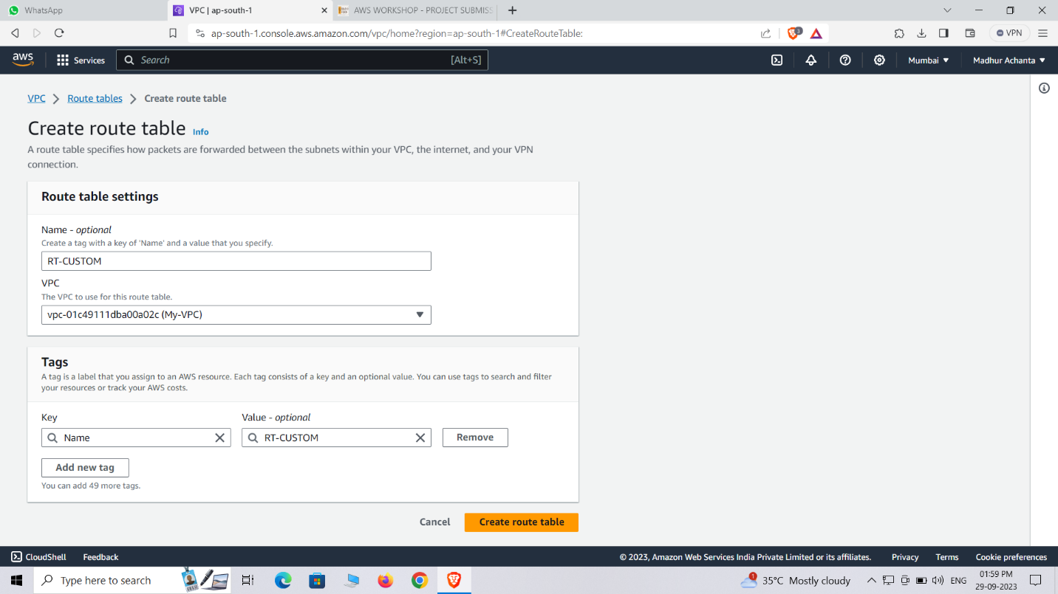

Edit name as RT-main of VPC RT

Click create route table and give name as RT-CUSTOM

Select MY-VPC which we created

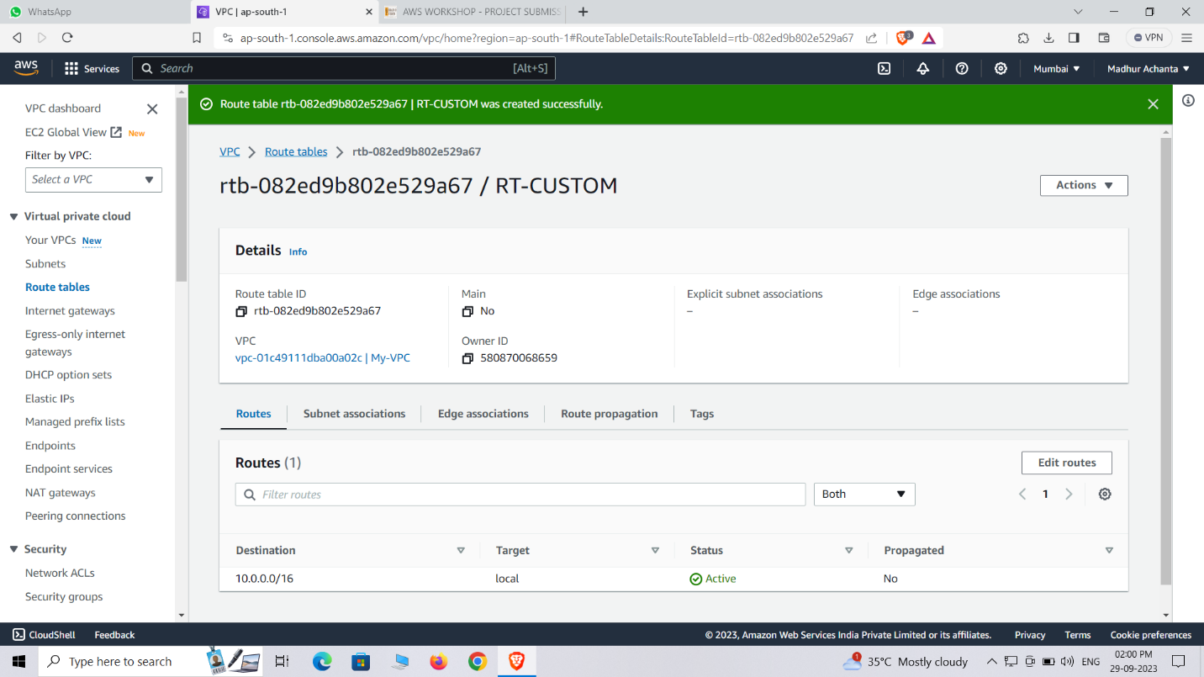

PART:-6

Now attach the PUBSUBNET to RT-CUSTOM

Click subnet association

Now click on edit subnet association

Now select PUB subnet and save it.

Now click edit routes then click on add route

In target click IGW and give PUBLIC (0.0.0.0/0) as destination

Now click save changes

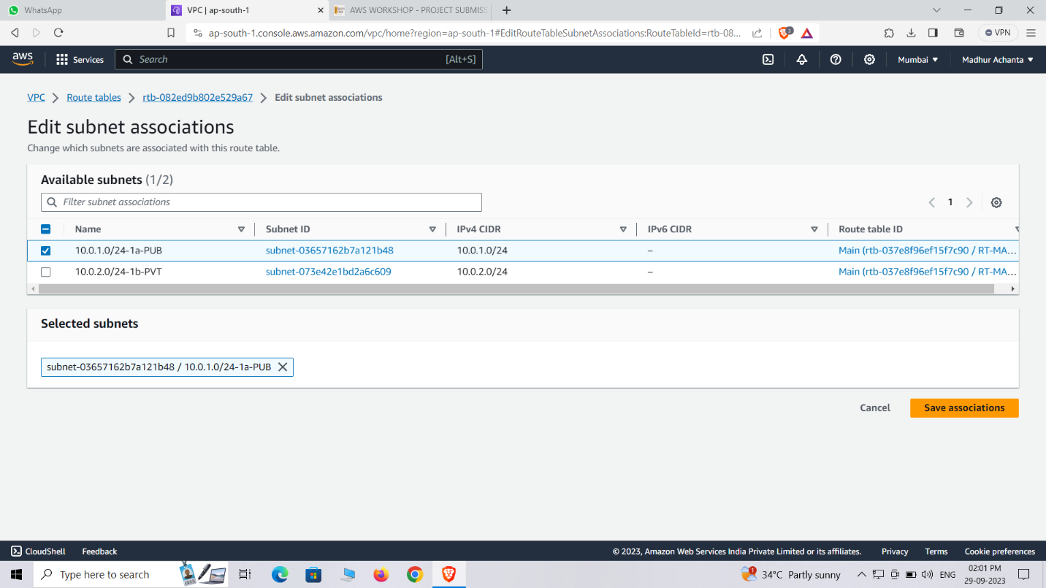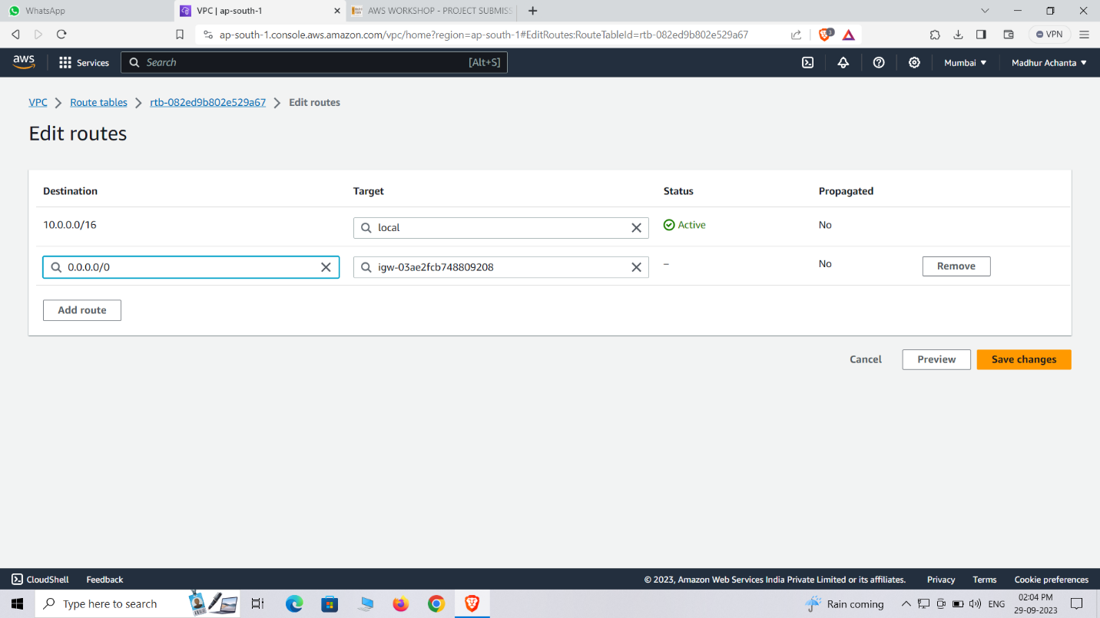

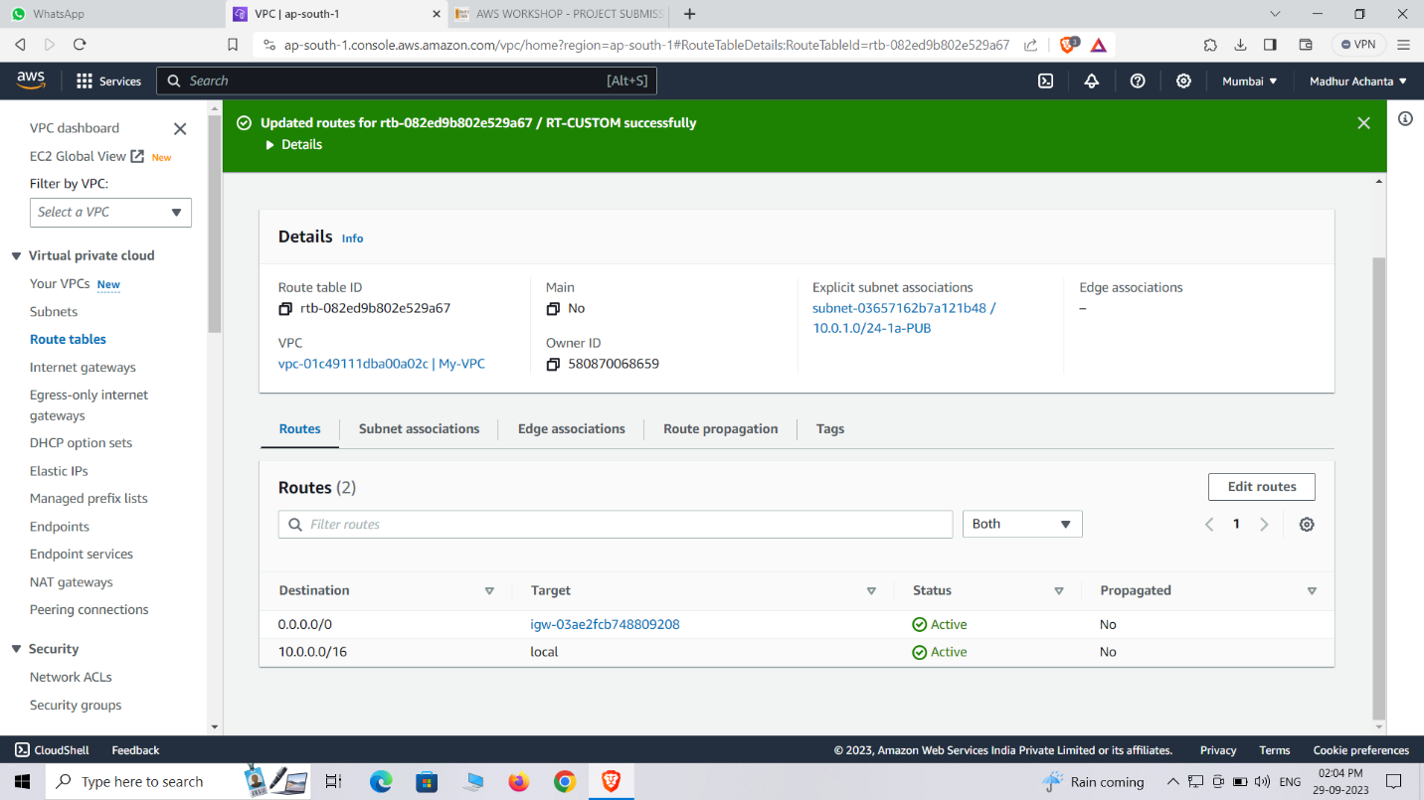

PART:-7

Creating NAT(Network Address Translation)

**Network Address Translation (NAT)** is a technology that allows instances within a private subnet in AWS to access the internet by translating their private IP addresses to public IP addresses.

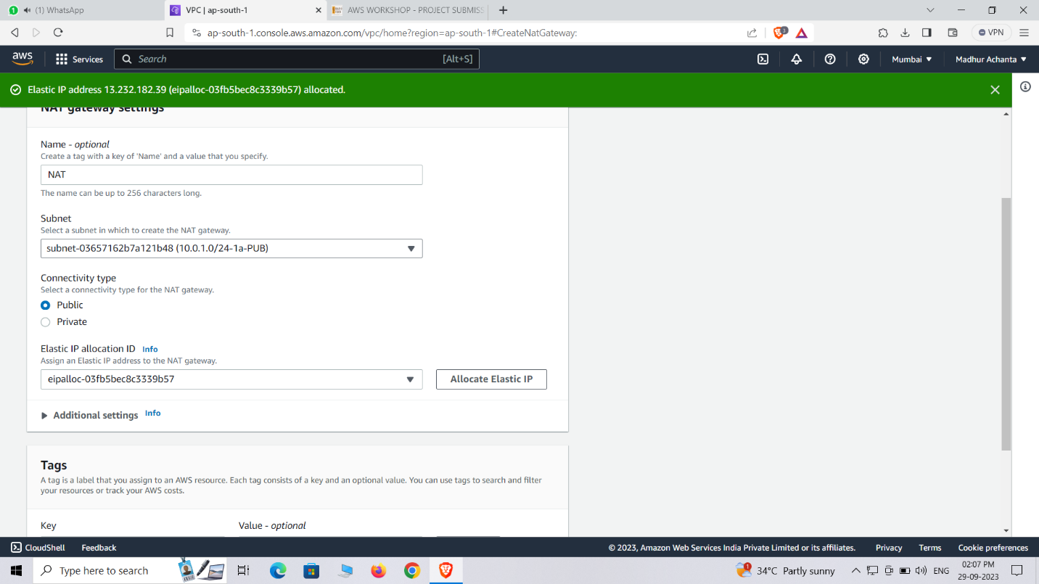

Click NAT gateways, create NAT gateway

Giver name as NAT

Select PUB subnet which we created before

Click on allocate elastic IP then create NAT gateway

Click route tables

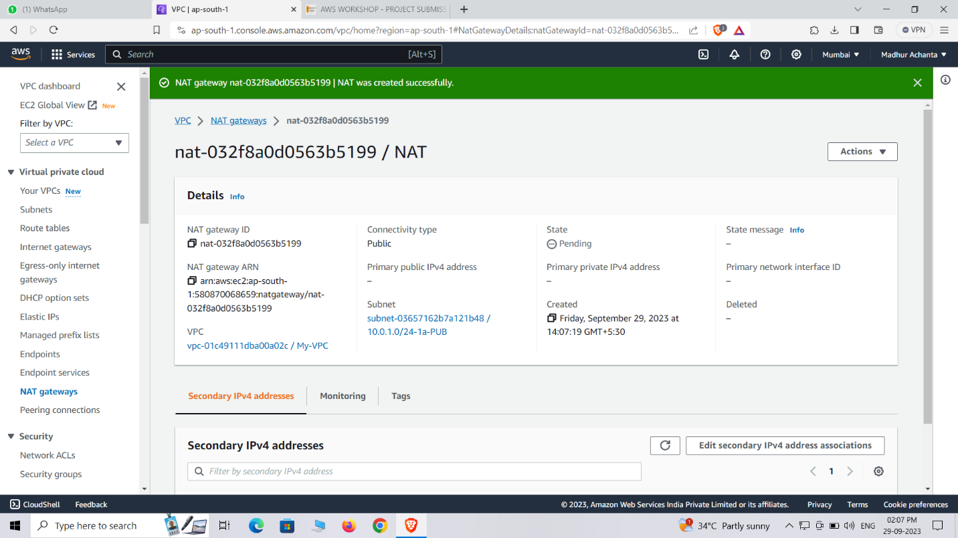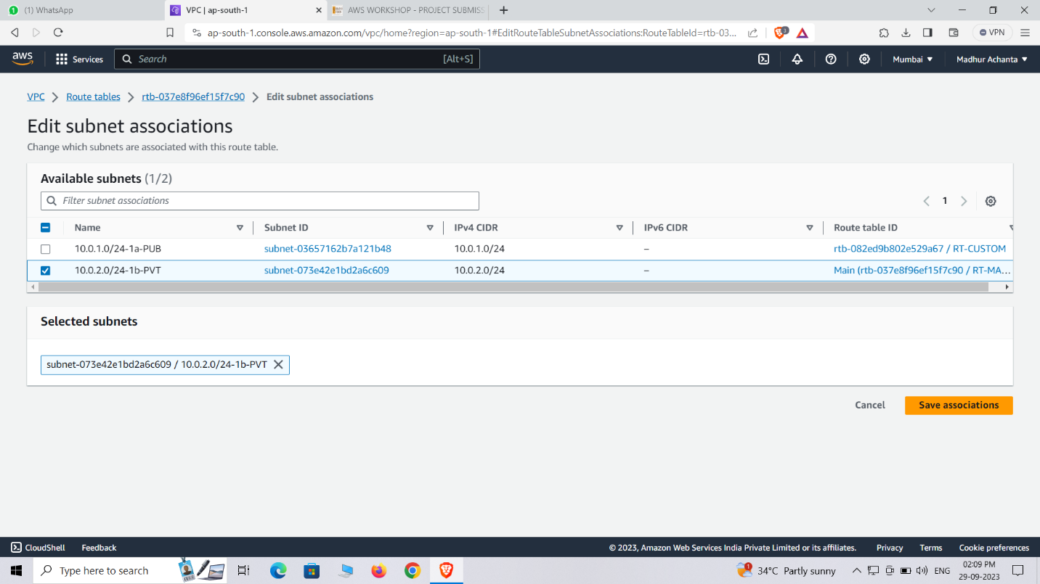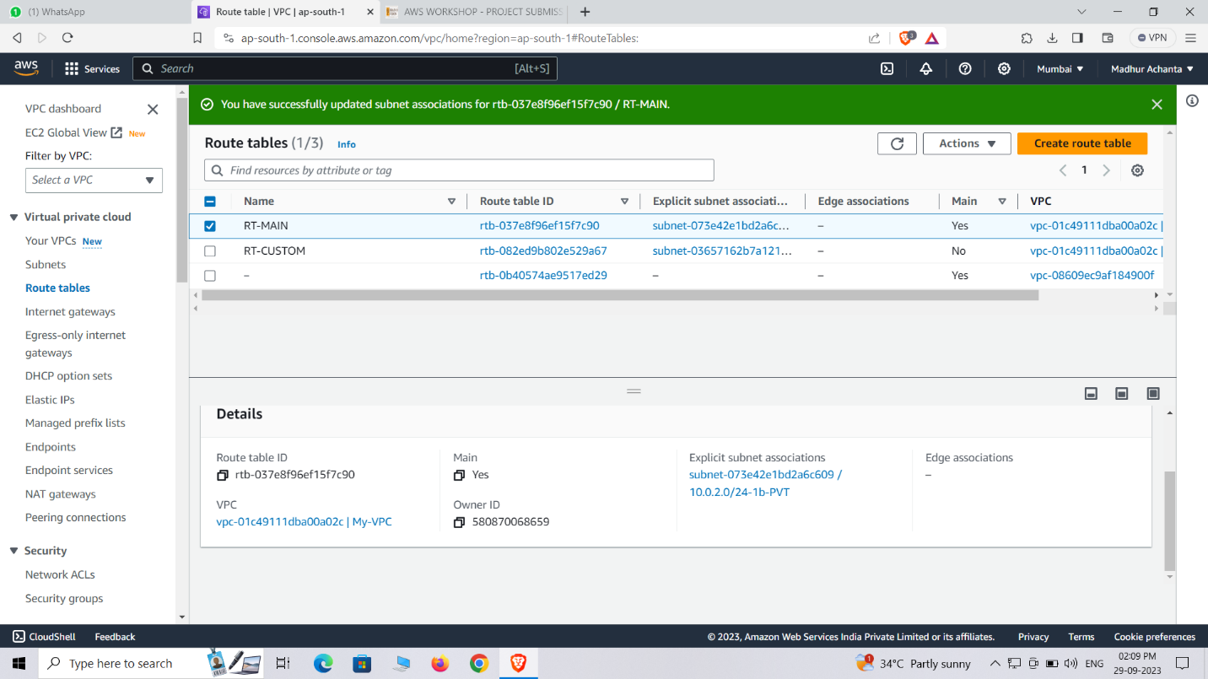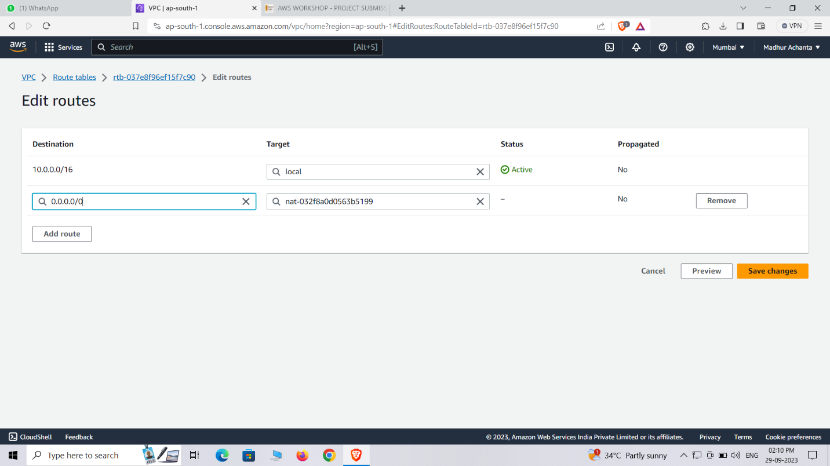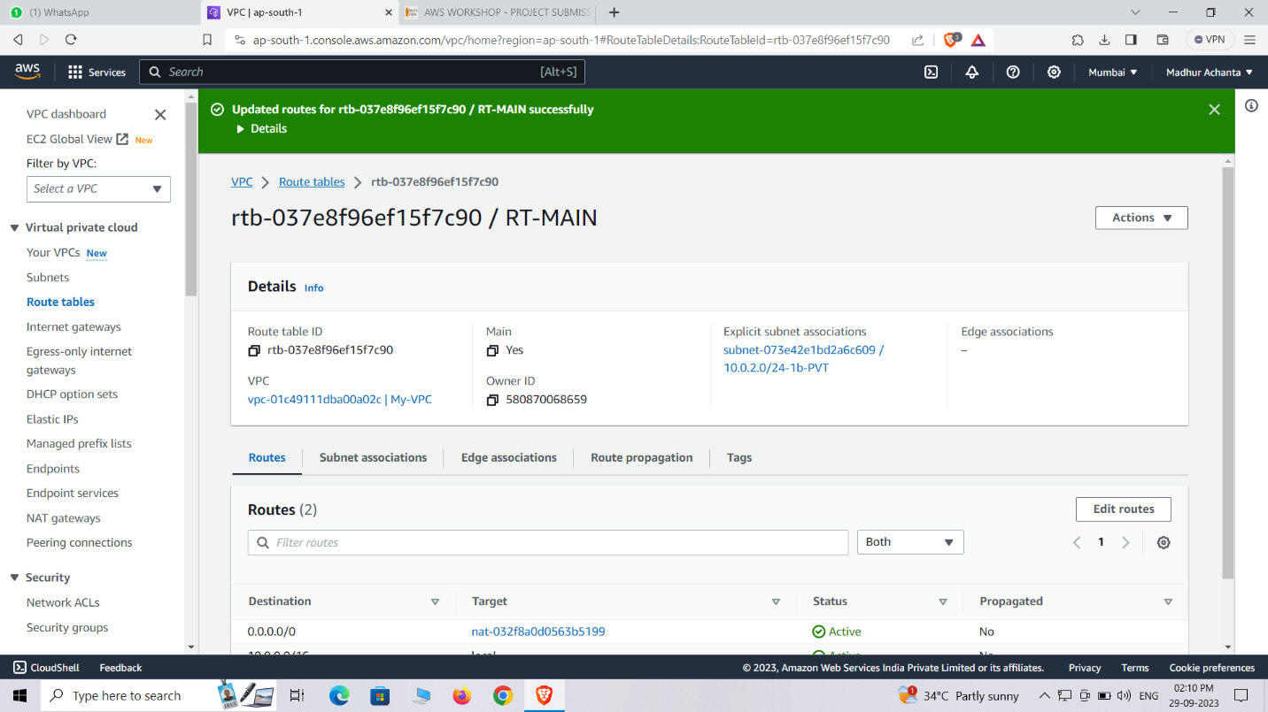

Select RT-MAIN

Select subnet association then edit it

Click on PVT and save association

Click routes then edit routes then add routes

Select target as NAT and destination as PUBLIC and then save the changes

# **LEVEL:-2**

We need to launch a webserver in the public subnet using Auto Scaling Group and create a S3 bucket using IAM role and upload an image to the bucket.

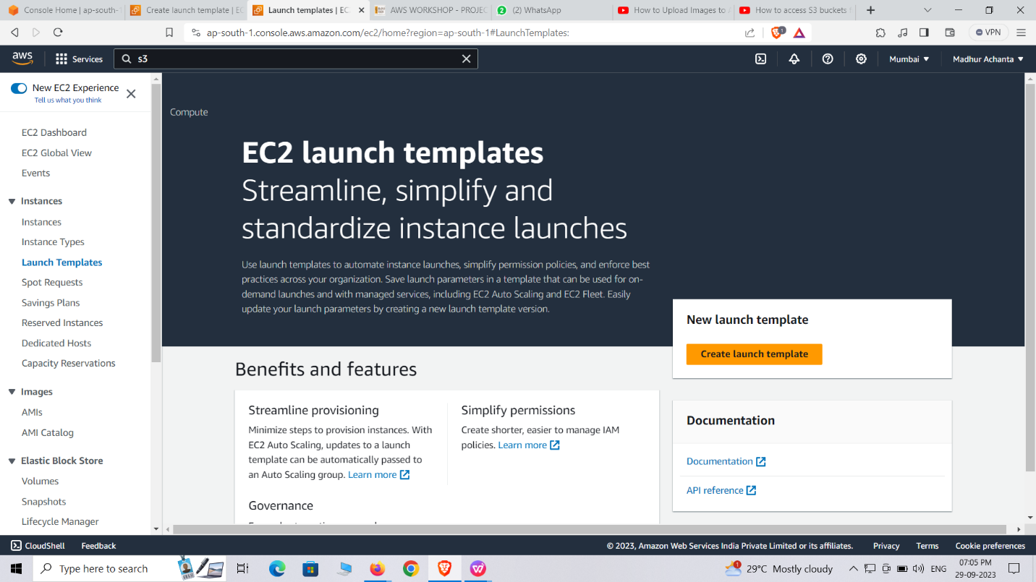

This was launched in the existing VPC only

**Classic Load Balancer:** A Classic Load Balancer operates at the transport layer (Layer 4) and routes traffic based on network information such as IP addresses and ports. It performs health checks on registered instances and automatically distributes incoming traffic across those instances to ensure efficient utilization and fault to tolerance.

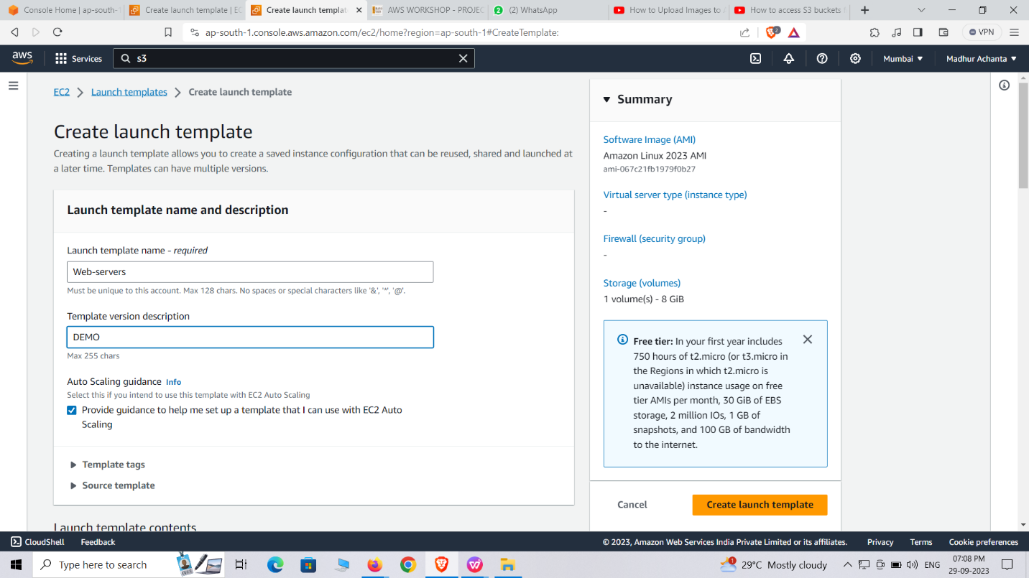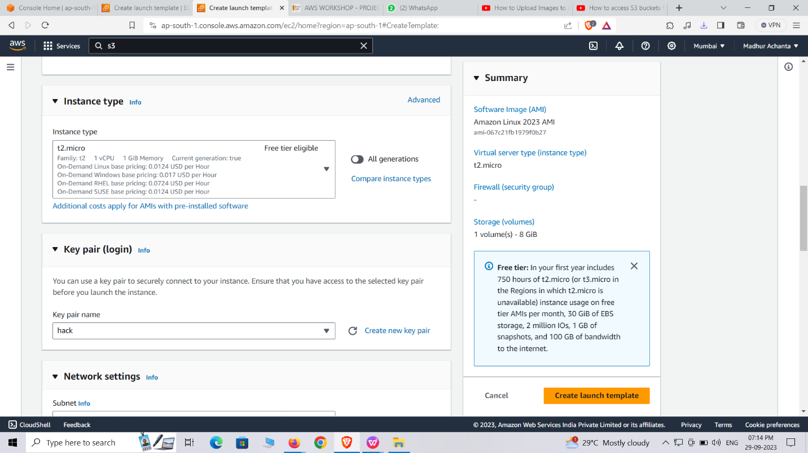

**Steps to create a Classic Load Balancer:**

Open the Amazon EC2 service in the AWS Management Console.

Click on "Load Balancers" in the left-hand navigation panel.

Click on the "Create Load Balancer" button.

Choose "Classic Load Balancer" as the load balancer type.cbl

Configure the basic settings:

Provide a name for your load balancer.

Select the appropriate VPC or the EC2-Classic network. Define the health check parameters to monitor the health of the instances. Review the configuration and click on the "Create" button.

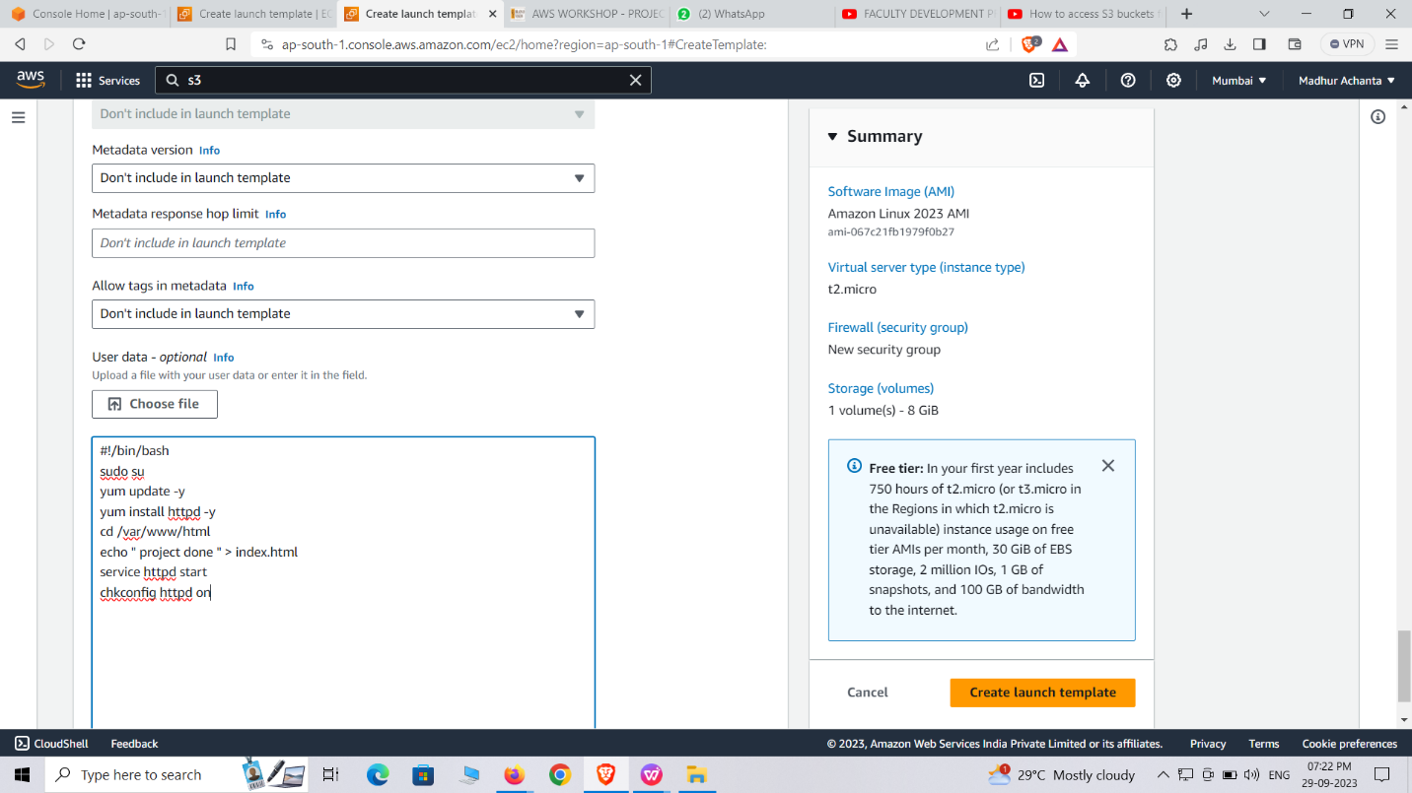

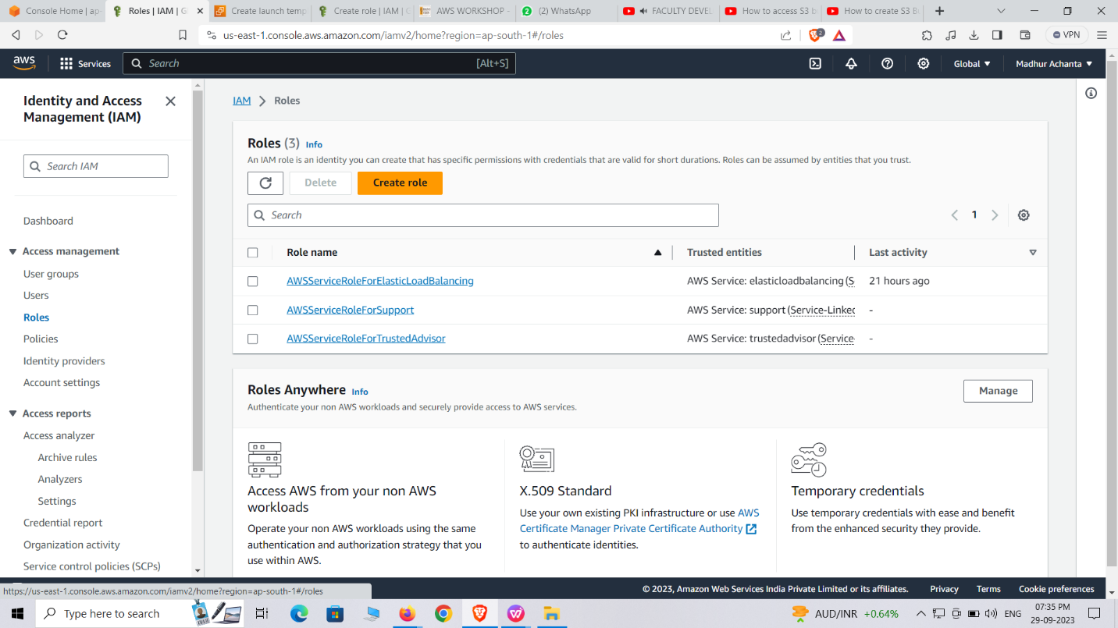

**Auto Scaling Group (ASG):** Auto Scaling Group manages a group of EC2 instances and automatically adjusts the number of instances based on scaling policies and health checks. ASG maintains a desired capacity of instances, scales up or down based on defined conditions, and replaces unhealthy instances to ensure the desired state of the application.

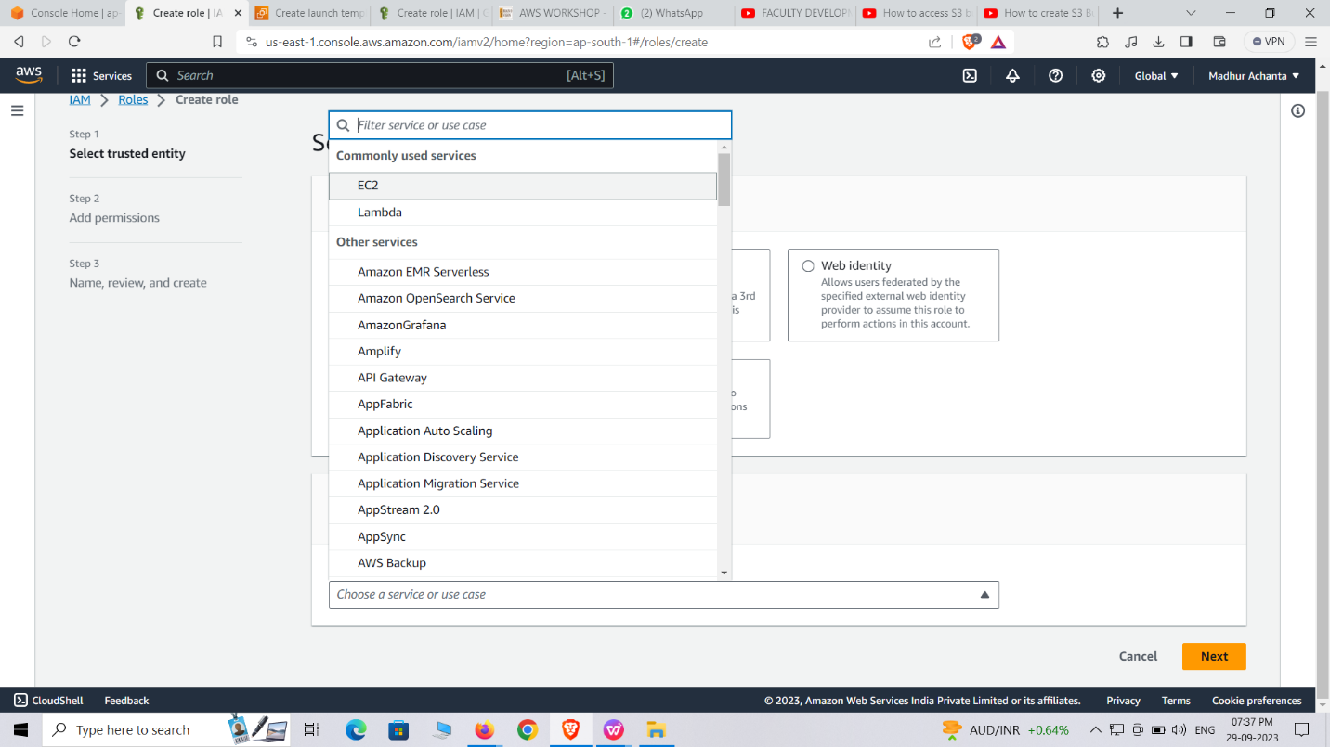

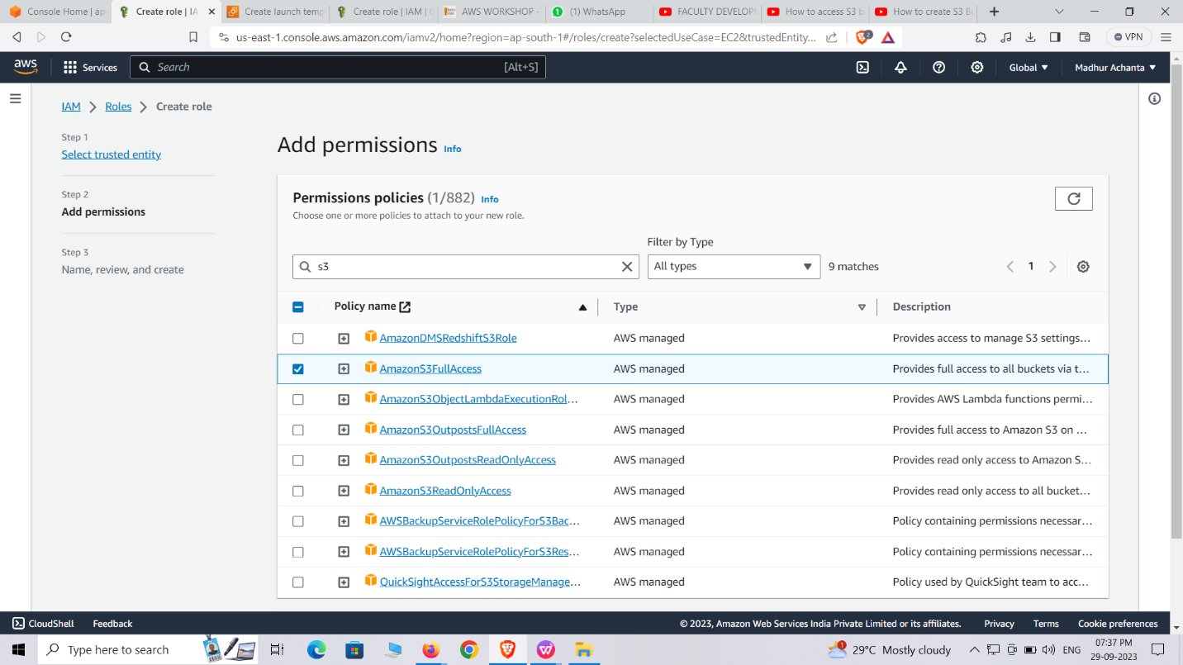

**Steps to create an Auto Scaling Group:**

1. Open the Amazon EC2 service in the AWS Management Console.

2. Click on "Auto Scaling Groups" in the left-hand navigation pane.

3. Click on the "Create Auto Scaling Group" button.

4. Configure the Auto Scaling Group:

- Provide a name for your Auto Scaling Group.

- Select the appropriate launch template or launch configuration.

- Specify the desired capacity, minimum and maximum instances, and the subnet(s) for your instances.

5. Configure scaling policies(optional)

6. Configure notifications (optional)

- Set up email notifications for scaling events or policy breaches if desired.

8. Configure tags (optional):

- Add any tags to label and categorize your Auto Scaling Group.

9. Review the configuration and click on the "Create Auto Scaling Group" button.

**Webserver**: A web server in AWS is a virtual machine or container running web server software to host websites and web applications in the cloud.

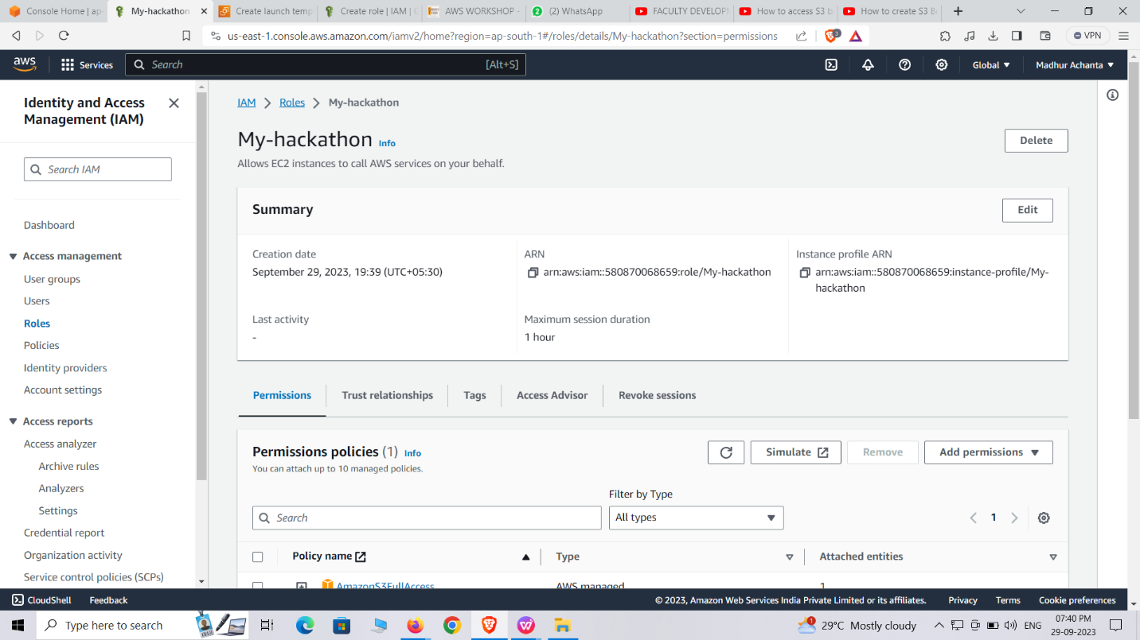

**To set up a web server in AWS:**

1. Launch an EC2 instance, choose an appropriate Amazon Machine Image (AMI) with pre-installed web server software, configure security groups, and assign an Elastic IP if needed.

2. Connect to the instance, install any additional dependencies or modules, configure the web server software (e.g., Apache, Nginx), upload website files, and configure DNS or load balancer settings to direct traffic to the web server.

**CREATING IAM:**

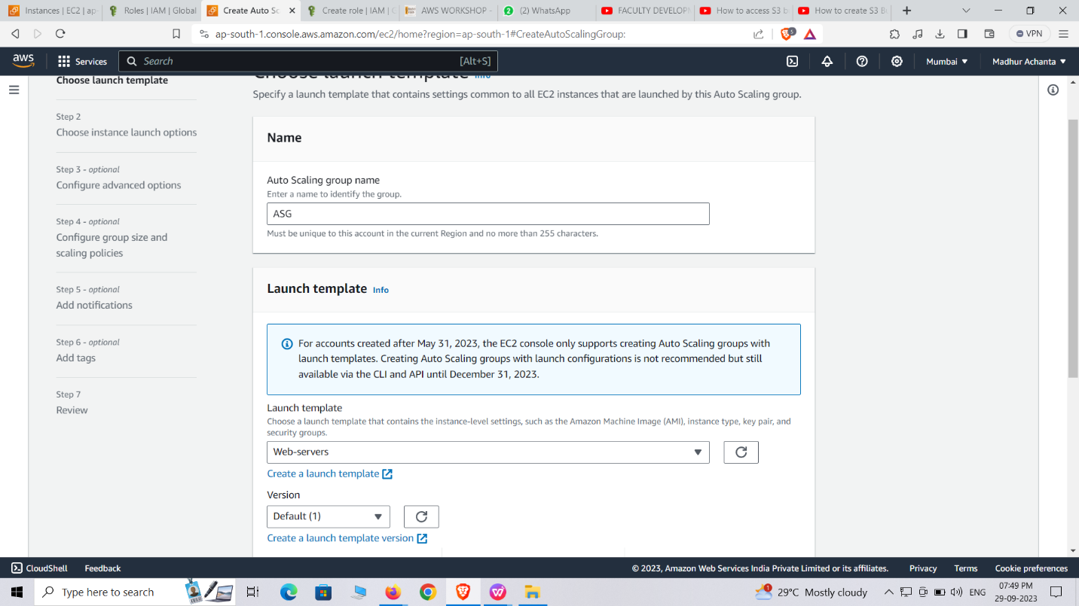

**CREATING BUCKET (S3):**

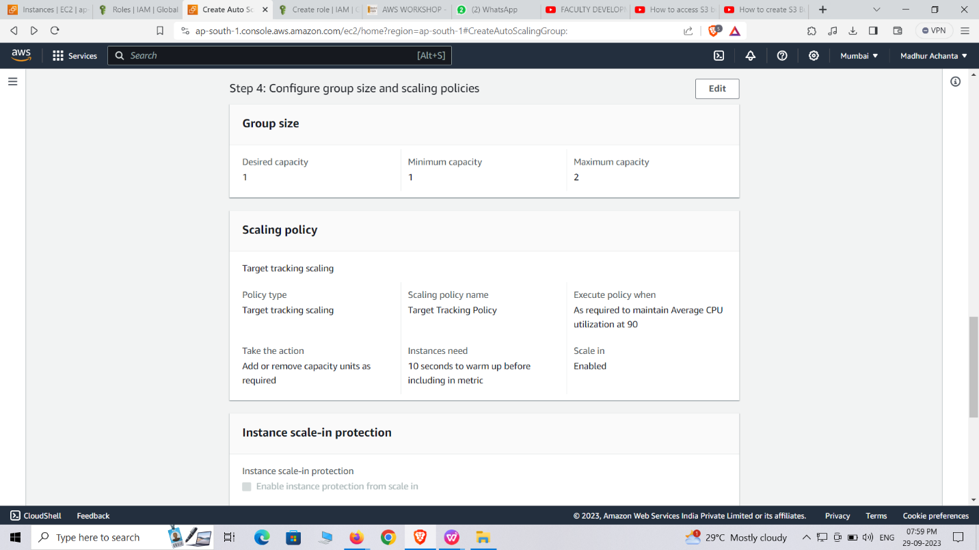

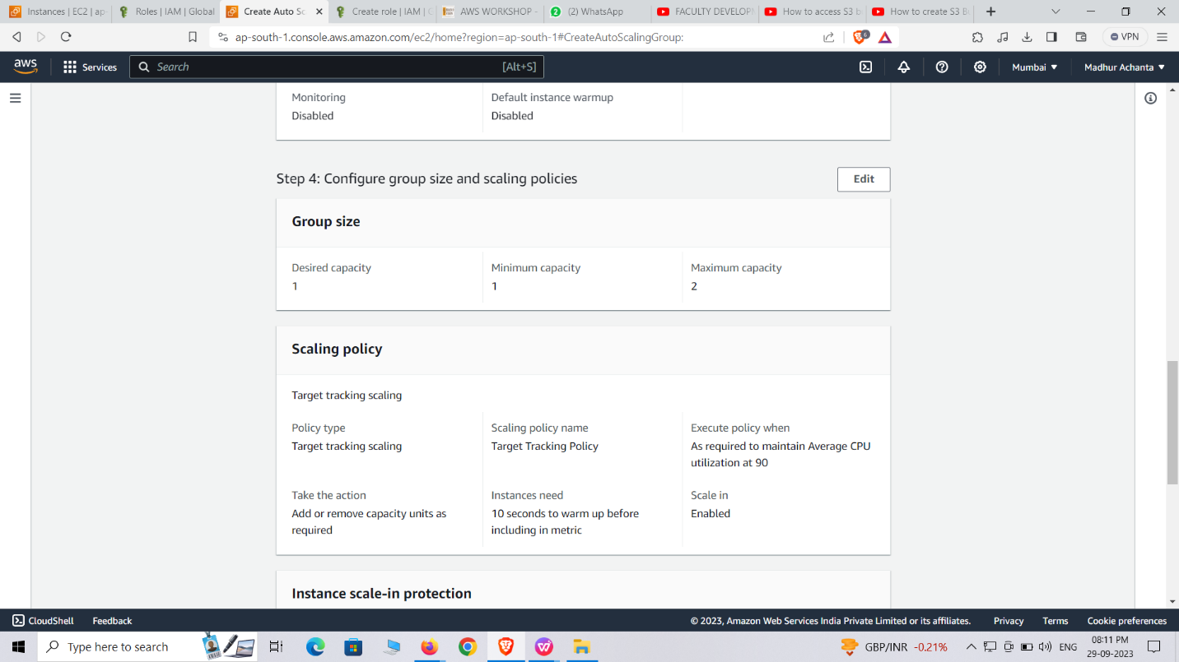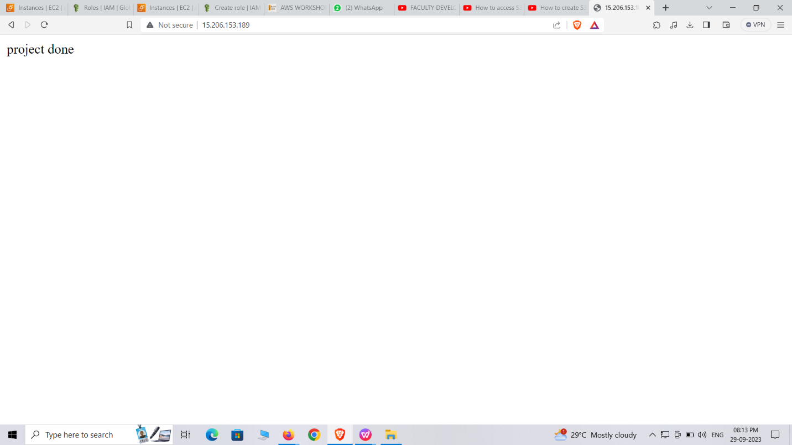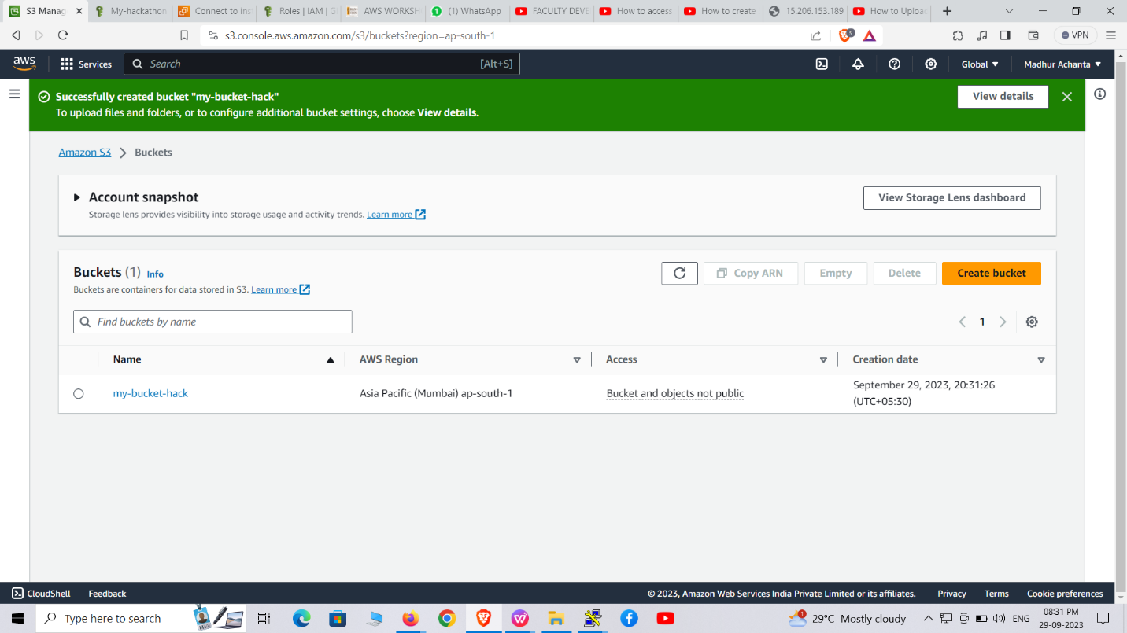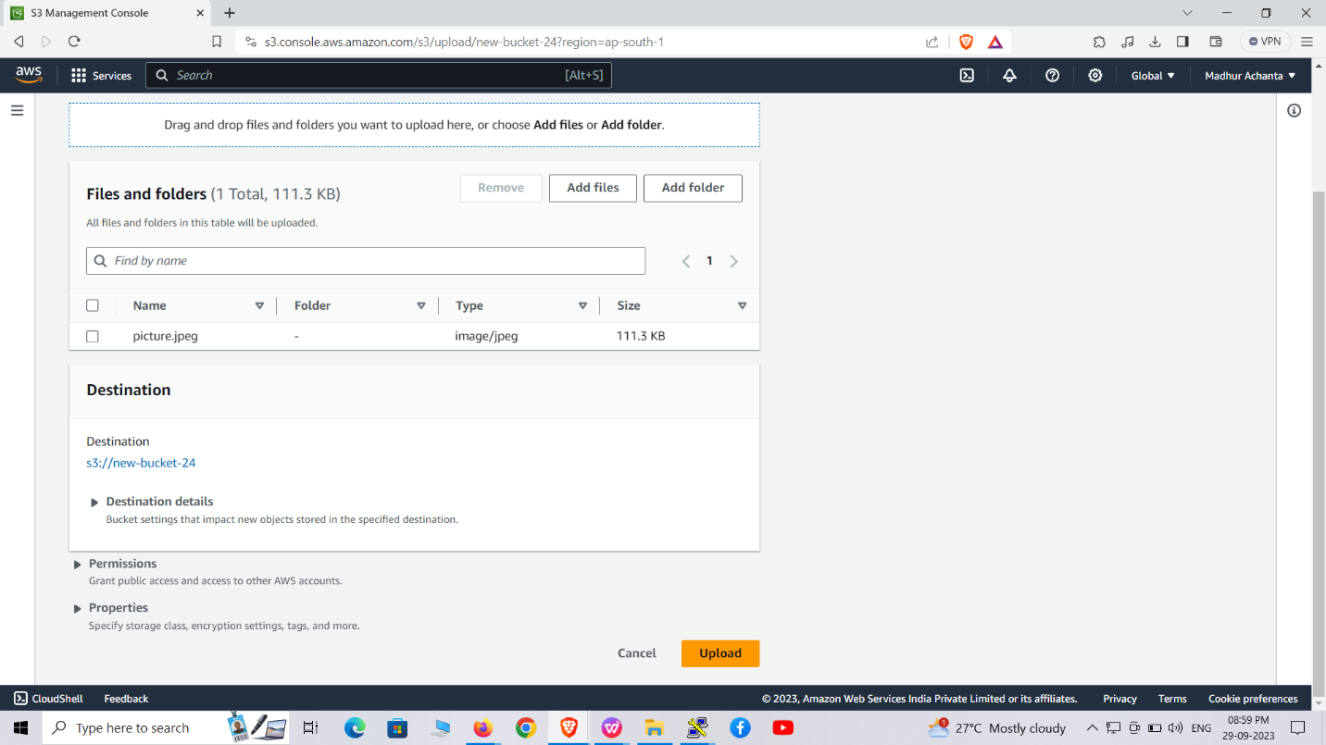

**DISPLAYING IMAGE:**

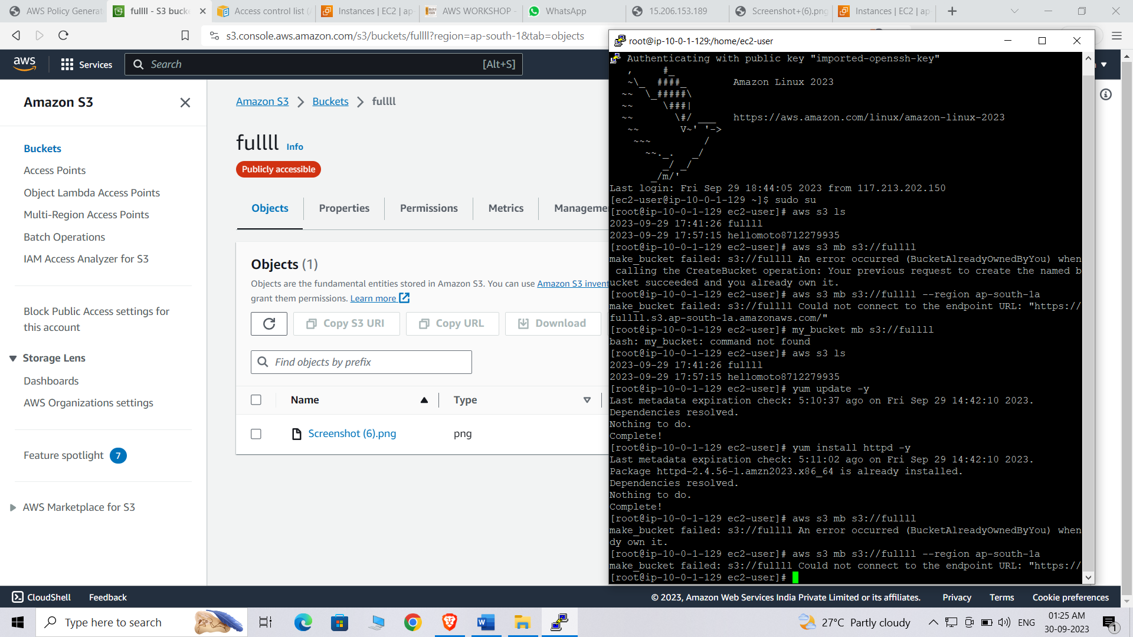



**LEVEL:-3**

**Part:-1**

Launching Database :-

Click on the launch instances

Give name as data servers

Select AMI(Amazon Machine Image) as linux

Select t2.micro which is free instances

Now select the existing key pair which is named as hack

Now go to the network settings and select VPC & PRIVATE subnet

Now go to the the inbound security group in that select source type as my IP

Now select the type as MYSQL/Aurora and give the source as 10.0.2.0/24

And give the description as mysql give linux scripts and click on the launch instances

Then the instance has been launched

**Part:-2**

**Creating instances**:-

For creating launch instances

Click on launch instances

Give name as jump/baston

Now select the AMI(Amazon Machine Image) as linux

Now select instances type as t2.micro which is free tier

And give the existing key pair

Now go to the network settings and give VPC

And give subnet as PUBLIC subnet

Give SG as jump and description as jump

Now go to advanced settings and type linux scripts

Connect the jump private IP address to database SSH

Now go to security group and edit the inbound rules

Remove IP given to SSH

Enter the copied address then save rules